Hópverkefni 1 Kolbeinn og Ágúst  
  
Entities:

1. Busses
2. Routes
3. Drivers
4. Towns
5. Garage
6. Stage

Relationships:

1. Busses M-1 Routes
2. Stage 1-M Drivers
3. Routes 1-M Stage
4. Towns 1-M Garage
5. Stage M-M Towns

Attributes:

1. Busses
   1. r_number (primary key)
   2. passengers
   3. decks
   4. route_nr (foreign key)
2. Routes
   1. route_nr (primary key)
   2. ppd
3. Drivers
   1. employee_nr
   2. f_name
   3. l_name
   4. street
   5. house_nr
   6. ph_number (NULL)
   7. stage_id (foreign key)
4. Towns
   1. town_nr (primary key auto_increment)
   2. name
   3. zip_code
   4. Garage_nr (foreign key) (NULL) -
5. Garage
   1. nr (primary key auto_increment)
   2. capacity
   3. street
   4. house_nr
6. Stage
   1. Stage_id (primary key auto increment)
   2. Route_id (foreign key) –
7. Stage_Town
   1. Stage_id (primary and foreign key)-
   2. Town_nr (foreign key)-

Data types:

|  |  |  |
| --- | --- | --- |
| Attribute | Data type | Size |
| Route_nr | Int | Default |
| Ppd | Int | Default |
| Employee_nr | Int | default |
| F_name | Varchar | 18 |
| L_name | Varchar | 18 |
| Street_name | Varchar | 25 |
| House_nr | Int | default |
| Phone_nr | Varchar | 20 |
| Stage_id (foreign key) | Int | default |
| R_number | char | 5 |
| Passengers | Int | Default |
| Decks | Int | Default |
| Route_nr (foreign key) | Int | Default |
| Garage_nr | Int | Default |
| Capacity | Int | Default |
| Street_name | varchar | 25 |
| House_nr | Int | Default |
| Town_nr | Int | Default |
| Town_name | Varchar | 25 |
| Zip_code | Char | 3 |
| Garage_number (foreign key) | Int | Default |
| Stage_id | Int | Default |
| Route_id (foreign key) | Int | Default |
| Stage_nr (foreign key) | Int | Default |
| Town_nr (foreign key) | Int | default |

ER diagram:  
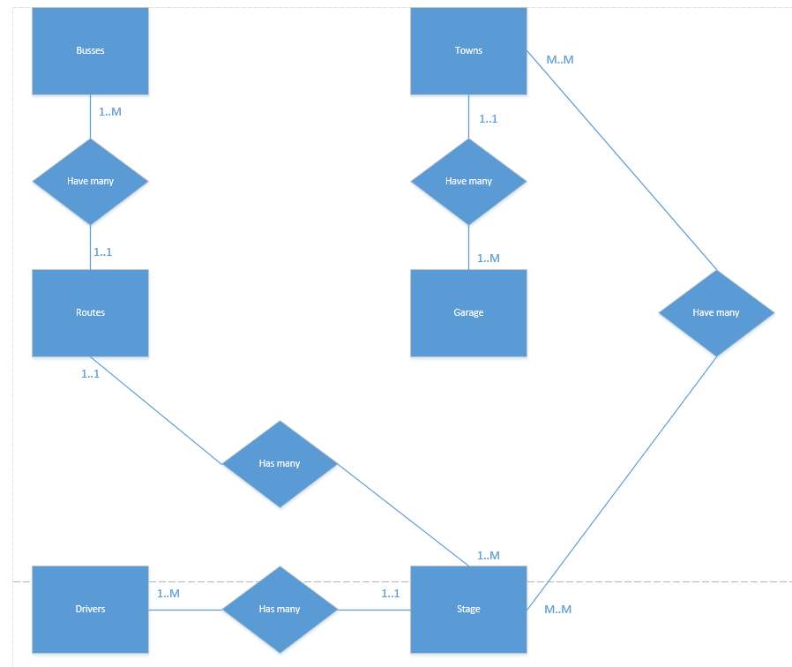

ER mapping:

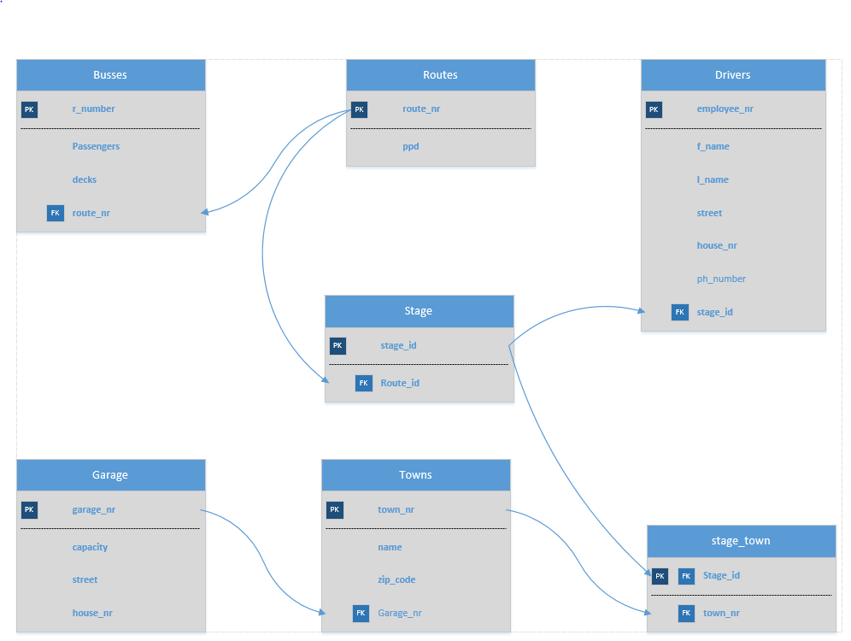

create database 0908002640_bus_db;

use 0908002640_bus_db;

create table Routes(

route_nr int auto_increment primary key,

ppd int not null

);

create table Drivers(

employee_nr int auto_increment primary key,

f_name varchar(18) not null,

l_name varchar(18) not null,

street_name varchar(25) not null,

house_nr int not null,

phone_nr varchar(20) NULL,

stage_id int not null,

foreign key(stage_id) references Stage(stage_id)

);

create table Busses(

r_number char(5) primary key,

passengers int not null,

decks int not null,

route_nr int not null,

foreign key (route_nr) references Routes(route_nr)

);

create table Garage(

garage_nr int auto_increment primary key,

capacity int not null,

street_name varchar(25) not null,

house_nr int not null

);

create table Towns(

town_nr int auto_increment primary key,

town_name varchar(25) not null,

zip_code char(3) not null,

garage_number int null,

foreign key(garage_number) references Garage(garage_nr)

);

create table Stage(

stage_id int auto_increment primary key,

route_id int not null,

foreign key(route_id) references Routes(route_nr)

);

create table Stage_Town(

stage_nr int auto_increment primary key,

town_nr int not null,

foreign key(stage_nr) references Stage(stage_id),

foreign key(town_nr) references Towns(town_nr)

);